NAME : Shruti Rajesh Kayande

This one-page website is expertly designed using HTML, CSS, and vanilla JavaScript. It includes a sticky navigation bar that remains accessible while scrolling, along with an animated hamburger menu for smaller screens. The **hero section** features a vibrant, animated gradient background that immediately catches attention, coupled with a strong headline and call-to-action button. Below that, the **features section** presents a clean, grid-based layout showcasing key benefits like responsive design, modern animation, and dark/light mode functionality. A **testimonial carousel** adds credibility, automatically cycling through customer feedback with smooth transitions. The **contact section** includes a form with built-in HTML5 validation to collect user messages effectively. A dark mode toggle is available in the navigation, allowing users to switch between light and dark themes seamlessly for accessibility and personal preference. All design elements are fully responsive, ensuring the site looks and functions beautifully on mobile phones, tablets, and desktops. The layout uses modern CSS techniques like Flexbox, Grid, and transitions for optimal performance and sleek UI/UX.

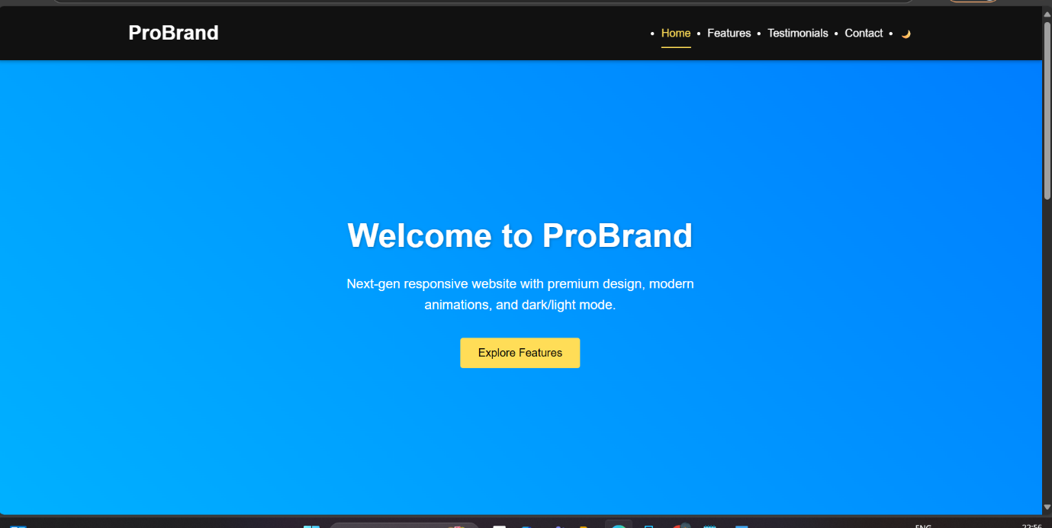

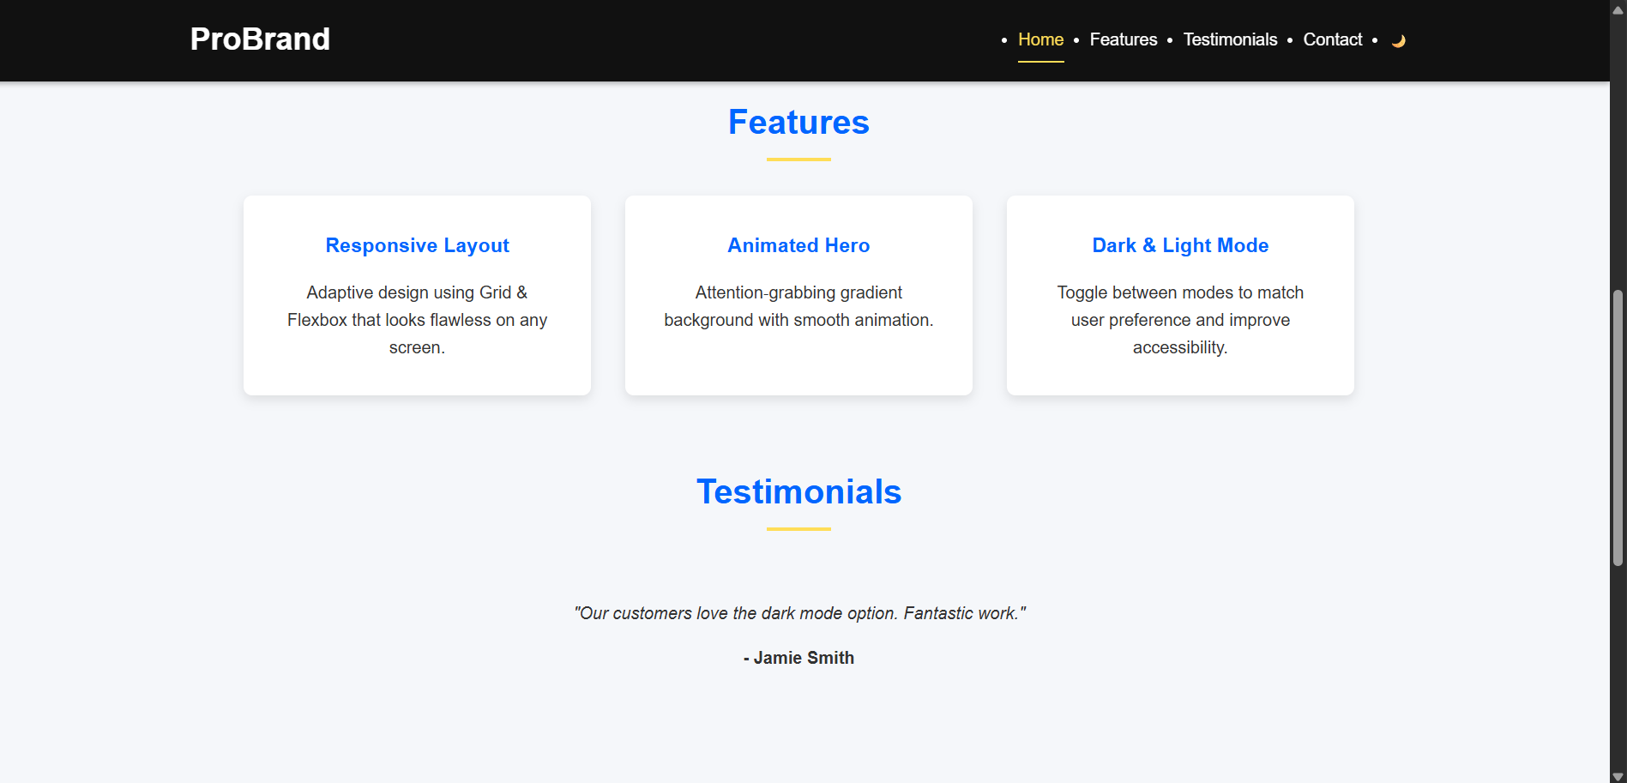

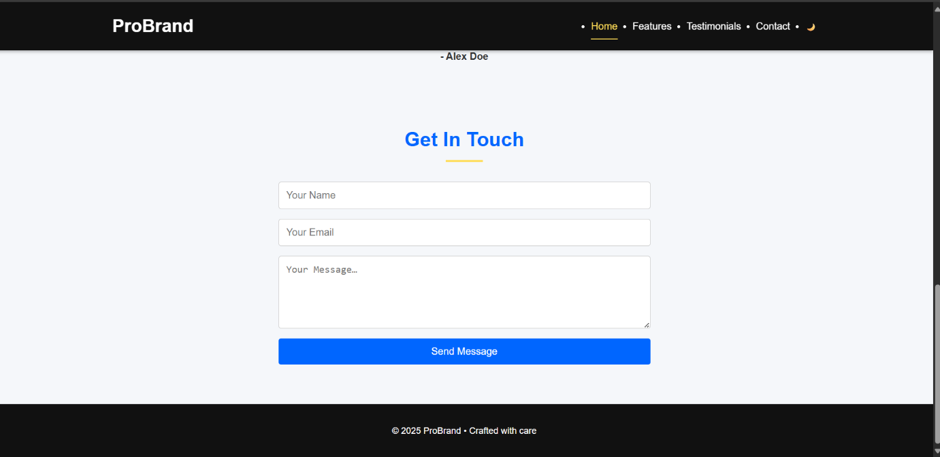

**PROGRAM:**

**<!DOCTYPE html>**

**<html lang="en">**

**<head>**

**<meta charset="UTF-8" />**

**<meta name="viewport" content="width=device-width, initial-scale=1.0"/>**

**<title>Pro Responsive Page</title>**

**<style>**

**:root {**

**--primary: #0066ff;**

**--accent: #ffdd57;**

**--bg-dark: #111;**

**--bg-light: #f5f7fa;**

**--text-light: #fff;**

**--text-dark: #333;**

**--transition: 0.3s ease;**

**}**

**\* { margin: 0; padding: 0; box-sizing: border-box; }**

**html { scroll-behavior: smooth; }**

**body {**

**font-family: 'Inter', sans-serif;**

**background-color: var(--bg-light);**

**color: var(--text-dark);**

**line-height: 1.6;**

**transition: background-color var(--transition), color var(--transition);**

**}**

**a { color: inherit; text-decoration: none; }**

**header {**

**position: sticky; top: 0; z-index: 999;**

**background: var(--bg-dark); color: var(--text-light);**

**box-shadow: 0 2px 5px rgba(0,0,0,0.3);**

**}**

**.navbar {**

**max-width: 1200px; margin: auto;**

**display: flex; justify-content: space-between;**

**align-items: center; padding: 1rem 2rem;**

**}**

**.logo { font-size: 1.8rem; font-weight: bold; }**

**.nav-links { display: flex; gap: 1.5rem; }**

**.nav-links a {**

**padding: 0.5rem 0; position: relative;**

**transition: color var(--transition);**

**}**

**.nav-links a:hover,**

**.nav-links a.active {**

**color: var(--accent);**

**}**

**.nav-links a.active::after {**

**content: '';**

**position: absolute; bottom: -5px; left: 0;**

**width: 100%; height: 2px; background: var(--accent);**

**}**

**.menu-toggle { display: none; font-size: 1.8rem; background: none; border: none; color: inherit; cursor: pointer; }**

**/* Hero with animated gradient */**

**.hero {**

**display: flex; flex-direction: column; align-items: center; justify-content: center;**

**text-align: center; height: 90vh; padding: 0 2rem;**

**background: linear-gradient(45deg, #0066ff, #00ccff, #0066ff);**

**background-size: 400% 400%;**

**animation: gradAnim 15s ease infinite;**

**color: var(--text-light);**

**}**

**@keyframes gradAnim {**

**0% { background-position: 0% 50%; }**

**50% { background-position: 100% 50%; }**

**100% { background-position: 0% 50%; }**

**}**

**.hero h1 {**

**font-size: 3rem; margin-bottom: 1rem; text-shadow: 1px 1px 4px rgba(0,0,0,0.3);**

**}**

**.hero p { font-size: 1.2rem; margin-bottom: 2rem; max-width: 600px; }**

**.hero button {**

**padding: 0.8rem 1.6rem; font-size: 1rem;**

**background: var(--accent); border: none; border-radius: 4px;**

**cursor: pointer; transition: opacity var(--transition);**

**}**

**.hero button:hover { opacity: 0.8; }**

**/* Sections */**

**.section {**

**max-width: 1100px; margin: 4rem auto;**

**padding: 0 2rem;**

**}**

**.section-title {**

**text-align: center; margin-bottom: 2rem;**

**font-size: 2rem; color: var(--primary);**

**position: relative;**

**}**

**.section-title::after {**

**content: ''; display: block; width: 60px; margin: 0.5rem auto;**

**height: 3px; background: var(--accent);**

**}**

**/* Feature grid */**

**.features {**

**display: grid; gap: 2rem;**

**grid-template-columns: repeat(auto-fit, minmax(250px, 1fr));**

**}**

**.feature {**

**background: var(--text-light); padding: 2rem;**

**border-radius: 8px; box-shadow: 0 4px 10px rgba(0,0,0,0.1);**

**text-align: center; transition: transform var(--transition);**

**}**

**.feature:hover { transform: translateY(-5px); }**

**.feature h3 { color: var(--primary); margin-bottom: 1rem; }**

**/* Testimonials carousel */**

**.testimonials { position: relative; overflow: hidden; }**

**.testimonial {**

**opacity: 0; position: absolute; top: 0; left: 0;**

**width: 100%; text-align: center; padding: 2rem;**

**transition: opacity 1s var(--transition);**

**}**

**.testimonial.active { opacity: 1; position: relative; }**

**.testimonial p { font-style: italic; margin-bottom: 1rem; }**

**.testimonial span { font-weight: bold; display: block; }**

**/* Contact form */**

**.contact form {**

**max-width: 600px; margin: auto;**

**display: flex; flex-direction: column; gap: 1rem;**

**}**

**.contact input, .contact textarea {**

**padding: 0.75rem; border: 1px solid #ccc;**

**border-radius: 4px; font-size: 1rem;**

**transition: border var(--transition);**

**}**

**.contact input:focus, .contact textarea:focus {**

**border-color: var(--primary); outline: none;**

**}**

**.contact button {**

**background: var(--primary); color: white;**

**border: none; padding: 0.75rem;**

**border-radius: 4px; font-size: 1rem; cursor: pointer;**

**transition: opacity var(--transition);**

**}**

**.contact button:hover { opacity: 0.9; }**

**footer {**

**background: var(--bg-dark); color: var(--text-light);**

**text-align: center; padding: 2rem 1rem; margin-top: 4rem;**

**font-size: 0.9rem;**

**}**

**/* Dark mode */**

**.dark-mode {**

**background-color: var(--bg-dark);**

**color: var(--text-light);**

**}**

**.dark-mode .feature { background: #222; box-shadow: 0 4px 10px rgba(0,0,0,0.5); }**

**.dark-mode input, .dark-mode textarea { background: #333; color: #eee; border-color: #555; }**

**/* Responsive */**

**@media(max-width:768px){**

**.menu-toggle { display: block; }**

**.nav-links {**

**display: none; flex-direction: column;**

**background: var(--bg-dark); width: 100%;**

**}**

**.nav-links.show { display: flex; }**

**.nav-links li { padding: 0.5rem; text-align: center;}**

**.hero h1 { font-size: 2.4rem; }**

**}**

**</style>**

**</head>**

**<body>**

**<!-- Navbar -->**

**<header>**

**<nav class="navbar">**

**<div class="logo">ProBrand</div>**

**<button class="menu-toggle" onclick="toggleMenu()">☰</button>**

**<ul class="nav-links" id="navLinks">**

**<li><a href="#home" class="active">Home</a></li>**

**<li><a href="#features">Features</a></li>**

**<li><a href="#testimonials">Testimonials</a></li>**

**<li><a href="#contact">Contact</a></li>**

**<li><button onclick="toggleDarkMode()" style="background:none;border:none;color:inherit;cursor:pointer;">🌙</button></li>**

**</ul>**

**</nav>**

**</header>**

**<!-- Hero -->**

**<section class="hero" id="home">**

**<h1>Welcome to ProBrand</h1>**

**<p>Next-gen responsive website with premium design, modern animations, and dark/light mode.</p>**

**<button onclick="document.getElementById('features').scrollIntoView({behavior:'smooth'});">Explore Features</button>**

**</section>**

**<!-- Features -->**

**<section class="section" id="features">**

**<h2 class="section-title">Features</h2>**

**<div class="features">**

**<div class="feature">**

**<h3>Responsive Layout</h3>**

**<p>Adaptive design using Grid & Flexbox that looks flawless on any screen.</p>**

**</div>**

**<div class="feature">**

**<h3>Animated Hero</h3>**

**<p>Attention‑grabbing gradient background with smooth animation.</p>**

**</div>**

**<div class="feature">**

**<h3>Dark & Light Mode</h3>**

**<p>Toggle between modes to match user preference and improve accessibility.</p>**

**</div>**

**</div>**

**</section>**

**<!-- Testimonials -->**

**<section class="section" id="testimonials">**

**<h2 class="section-title">Testimonials</h2>**

**<div class="testimonials">**

**<div class="testimonial active">**

**<p>"ProBrand transformed our online presence — beautiful and fast!"</p>**

**<span>- Alex Doe</span>**

**</div>**

**<div class="testimonial">**

**<p>"Our customers love the dark mode option. Fantastic work."</p>**

**<span>- Jamie Smith</span>**

**</div>**

**<div class="testimonial">**

**<p>"The responsive layout is perfect across desktop and mobile."</p>**

**<span>- Taylor Lee</span>**

**</div>**

**</div>**

**</section>**

**<!-- Contact -->**

**<section class="section contact" id="contact">**

**<h2 class="section-title">Get In Touch</h2>**

**<form onsubmit="alert('Thanks for reaching out!'); return false;">**

**<input type="text" name="name" placeholder="Your Name" required>**

**<input type="email" name="email" placeholder="Your Email" required>**

**<textarea name="message" rows="5" placeholder="Your Message…" required></textarea>**

**<button type="submit">Send Message</button>**

**</form>**

**</section>**

**<footer>&copy; 2025 ProBrand • Crafted with care</footer>**

**<script>**

**// Menu toggle**

**function toggleMenu() {**

**document.getElementById('navLinks').classList.toggle('show');**

**}**

**// Highlight active nav item**

**document.querySelectorAll('.nav-links a').forEach(link => {**

**link.addEventListener('click', () => {**

**document.querySelector('.nav-links a.active').classList.remove('active');**

**link.classList.add('active');**

**});**

**});**

**// Testimonial carousel**

**let current = 0;**

**const items = document.querySelectorAll('.testimonial');**

**setInterval(() => {**

**items[current].classList.remove('active');**

**current = (current + 1) % items.length;**

**items[current].classList.add('active');**

**}, 4000);**

**// Dark mode toggle**

**function toggleDarkMode() {**

**document.body.classList.toggle('dark-mode');**

**}**

**</script>**

**</body>**

**</html>**